**Name: Varsha JJ**

**Roll No: 48**

**Batch: B**

**Date: 28/03/22**

**NETWORKING & SYSTEM ADMINISTRATION LAB**

**Experiment No.: 2**

**Aim**

Familiarization of linux command.

**Procedure**

**16. cat –n filename :** To display line number.

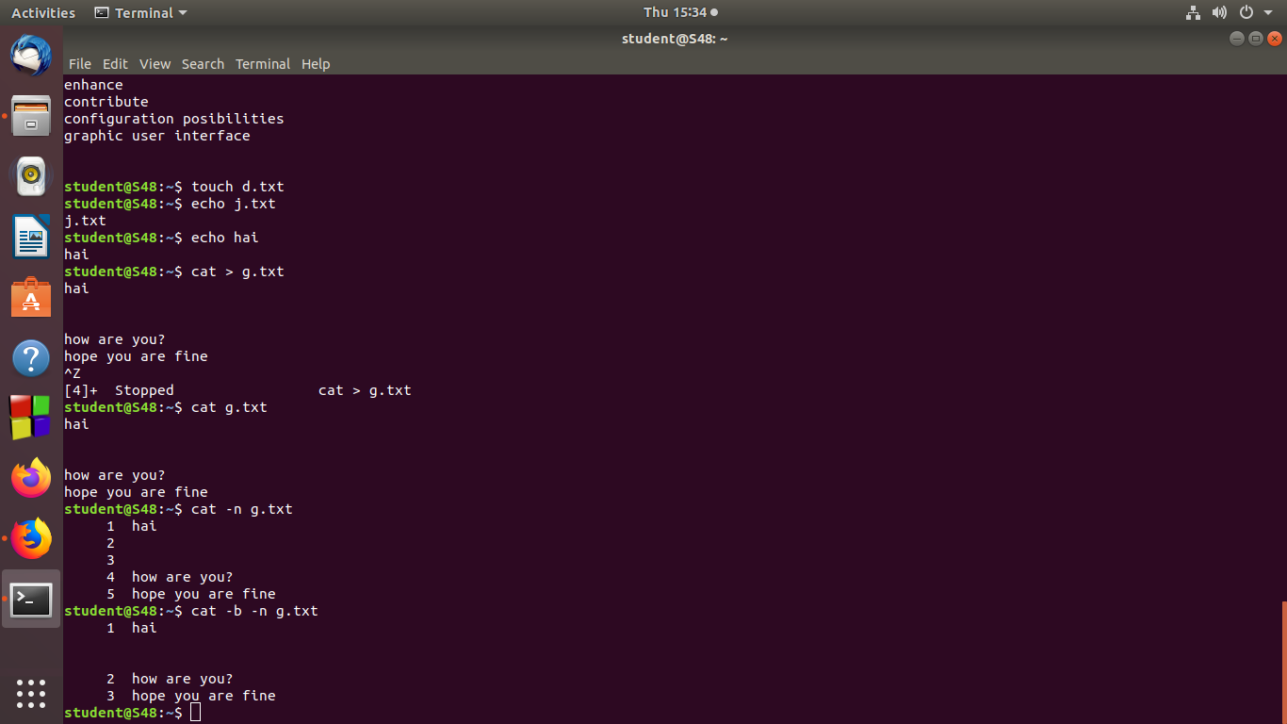

**17. cat –b filename :** To remove empty lines.



**18. touch filename :** To create a new blank file.

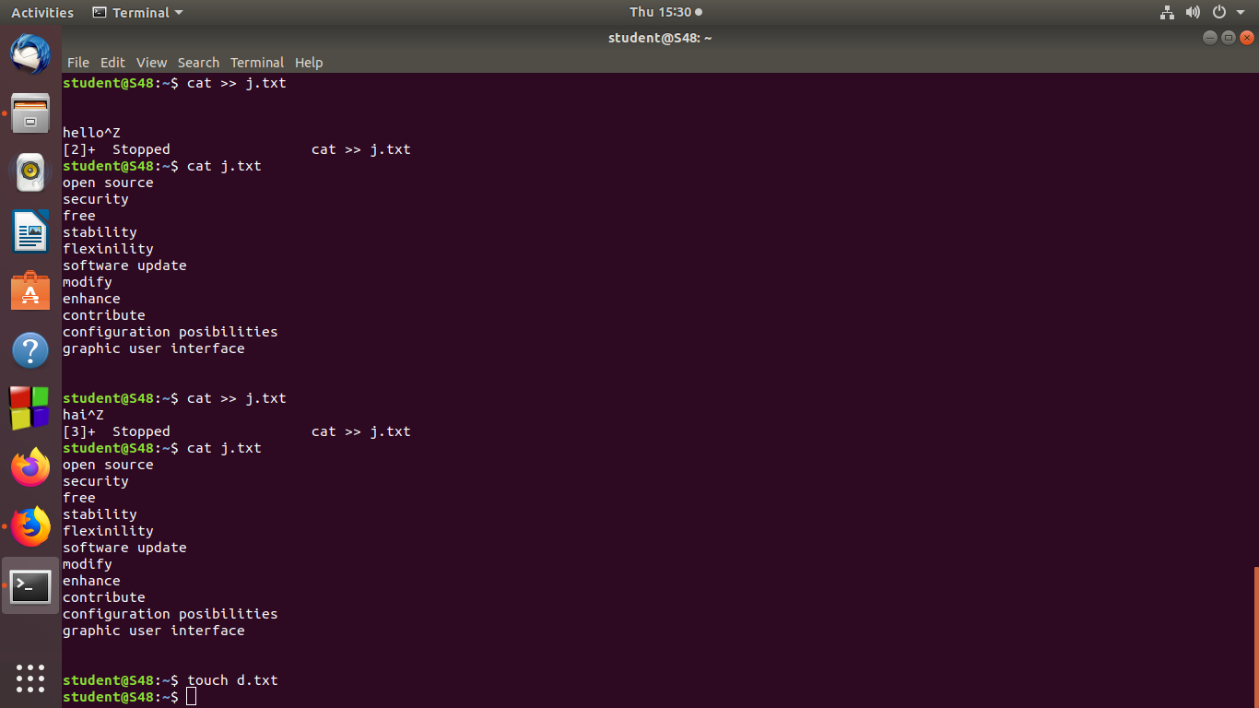

**19. echo > filename :**

**20. echo “ ” >> filename :** To append data from a command to the end of a text file.

**21. head filename :** To display first ten lines of specified file.

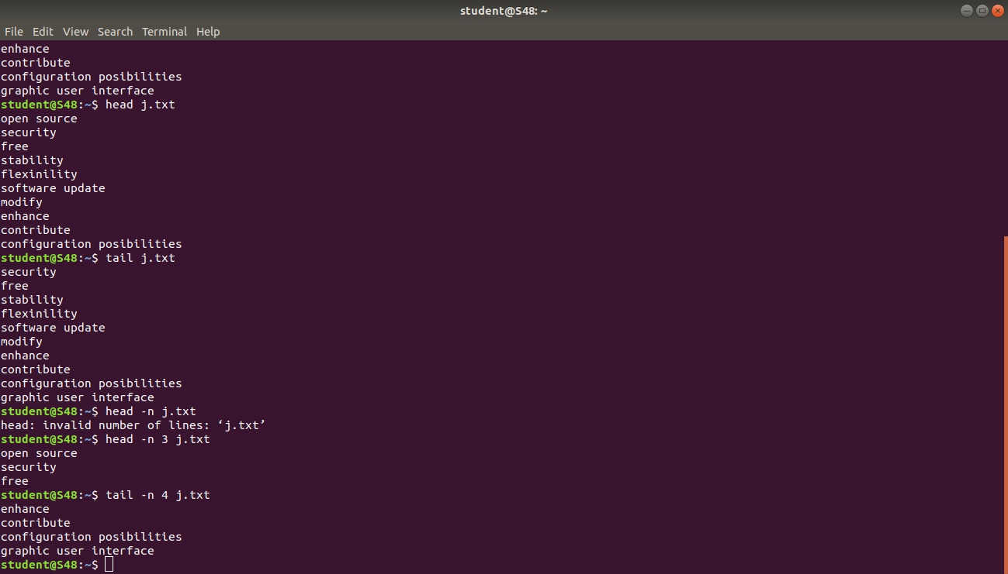

**22. head -n 3 filename :** Todisplay first specified number of lines instead of ten lines.



**23. tail filename :** To display last ten lines of specified file.



**24. tail -n filename :** Todisplay last specified number of lines instead of ten lines.



**25. cut -d- -f1 filename :** To cut a specific section by a delimiter.

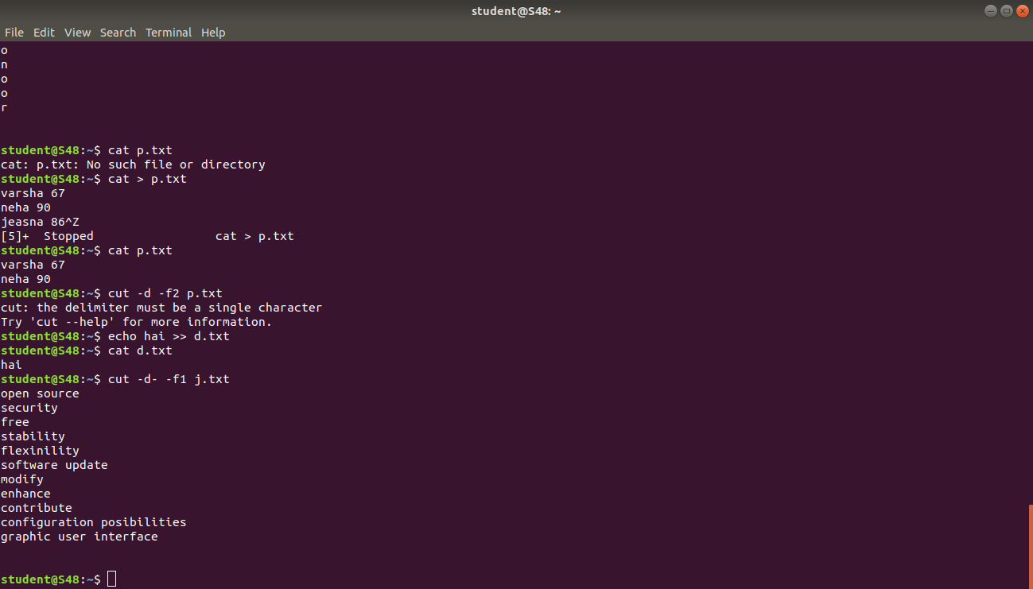

**Output Screenshot**